Litchfield Park and Recreation Commission
80 Doyle Road
Bantam, CT 06750

Litchfield Park and Recreation July 28, 2014
Meeting
Was cancelled
Due to lack of
Quorum

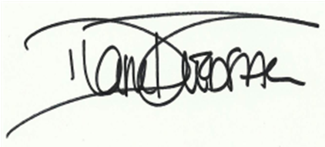

Diane Fredsall
Secretary

